**Experiment No. 8**

**Aim:** Create an application to call a phone number entered by the user the Edit Text.

**Program:**

* **Activity.xml :-**

*<?*xml version="1.0" encoding="utf-8"*?>*<RelativeLayout xmlns:android="http://schemas.android.com/apk/res/android"  
 xmlns:app="http://schemas.android.com/apk/res-auto"  
 xmlns:tools="http://schemas.android.com/tools"  
 android:layout_width="match_parent"  
 android:layout_height="match_parent"  
 tools:context=".MainActivity">  
  
  
  
 <EditText  
 android:layout_width="wrap_content"  
 android:layout_height="wrap_content"  
 android:id="@+id/et1"  
 android:layout_centerHorizontal="true"  
 android:textSize="20sp"  
 android:inputType="phone"  
 android:hint="Please Enter Your Phone Number"/>  
  
 <Button  
 android:layout_width="wrap_content"  
 android:layout_height="wrap_content"  
 android:id="@+id/bt"  
 android:onClick="call"  
 android:text="Call"  
 android:layout_centerHorizontal="true"  
  
 android:layout_marginTop="50dp"/>  
  
</RelativeLayout>

* **MainActivity.java :-**

package com.example.call;  
  
import androidx.appcompat.app.AppCompatActivity;  
import androidx.core.app.ActivityCompat;  
import android.Manifest;  
  
import android.content.Intent;  
import android.content.pm.PackageManager;  
import android.net.Uri;  
import android.os.Bundle;  
import android.view.View;  
import android.widget.Button;  
import android.widget.EditText;  
import android.widget.Toast;  
  
public class MainActivity extends AppCompatActivity {  
 EditText et1;  
 Button bt;  
 String num;  
  
 @Override  
 protected void onCreate(Bundle savedInstanceState) {  
 super.onCreate(savedInstanceState);  
 setContentView(R.layout.activity_main);  
 et1=findViewById(R.id.*et1*);  
 bt=findViewById(R.id.*bt*);  
 }  
  
 public void call(View view) {  
 Intent intent = new Intent(Intent.*ACTION_CALL*);  
 num = et1.getText().toString();  
 if(num.trim().isEmpty()){  
 intent.setData(Uri.*parse*("8530037679"));  
 }  
 else{  
 intent.setData(Uri.*parse*("tel: "+num));  
 }  
 if (ActivityCompat.*checkSelfPermission*(this,Manifest.permission.*CALL_PHONE*)!= PackageManager.*PERMISSION_GRANTED*){  
 Toast.*makeText*(this, "Please grant permission to call", Toast.*LENGTH_SHORT*).show();  
 requestPermission();  
 }  
 else {  
 startActivity(intent);  
 }  
 }  
  
 private void requestPermission() {  
 ActivityCompat.*requestPermissions*(this, new String[]{Manifest.permission.*CALL_PHONE*},1);  
 }  
  
}

* **AndroidManifest.xml:-**

*<?*xml version="1.0" encoding="utf-8"*?>*<manifest xmlns:android="http://schemas.android.com/apk/res/android"  
 xmlns:tools="http://schemas.android.com/tools">  
<uses-permission android:name="android.permission.CALL_PHONE" />  
 <application  
 android:allowBackup="true"  
 android:dataExtractionRules="@xml/data_extraction_rules"  
 android:fullBackupContent="@xml/backup_rules"  
 android:icon="@drawable/ic_launcher_foreground"  
 android:label="@string/app_name"  
 android:supportsRtl="true"  
 android:theme="@style/Theme.Call"  
 tools:targetApi="31">  
 <activity  
 android:name=".MainActivity"  
 android:exported="true">  
 <intent-filter>  
 <action android:name="android.intent.action.MAIN" />  
  
 <category android:name="android.intent.category.LAUNCHER" />  
 </intent-filter>  
 </activity>  
 </application>  
  
</manifest>

**Output:**

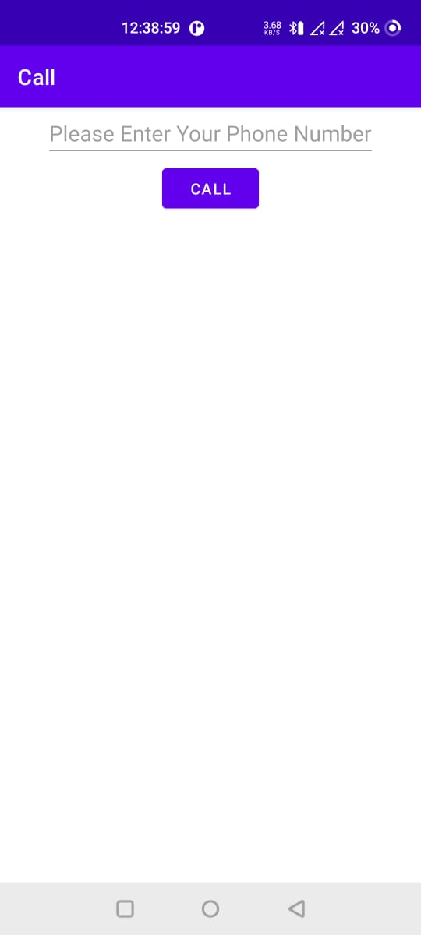 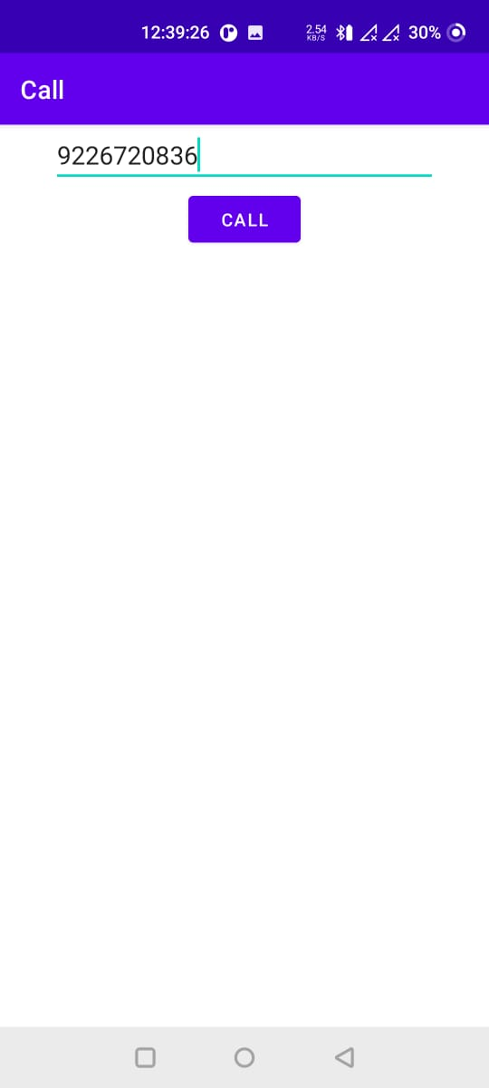

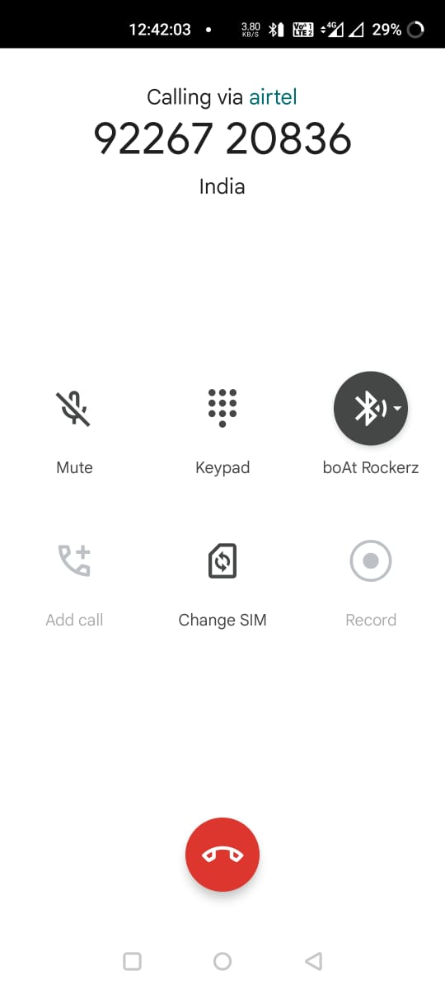



**Conclusion:**

Hence, by completing this experiment I came to know that how to Create an application to call a phone number entered by the user the Edit Text.

|  |  |  |  |
| --- | --- | --- | --- |
| **Writeup & Oral**  **(4)** | **Practical Performance**  **(4)** | **Attendance**  **(2)** | **Total**  **(10)** |
|  |  |  |  |